Taxi Dispatch Application Report

Problem Summary

Outline of the Development methodology

Requirements Specifications
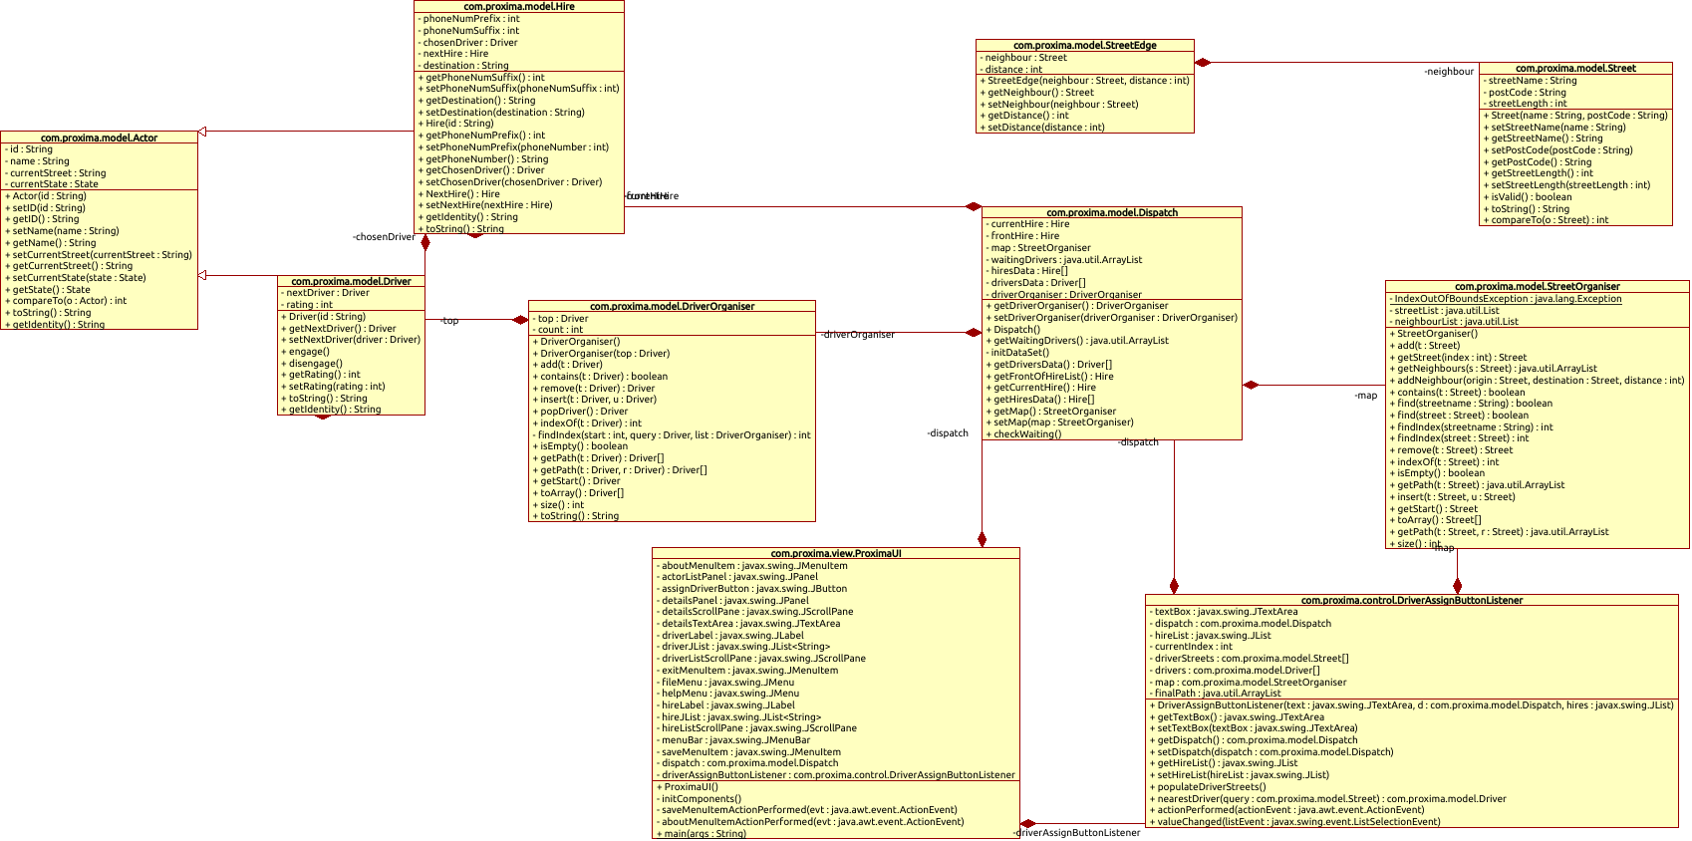

Evaluation

Conclusions

